JM Addington Annotated COVID-19 Operations Guide

This document is the plan that JM Addington will be using to keep employees and customers safe as we live and work alongside COVID-19. Text in green, such as this, has been added from the guide we released internally, to help explain our guide.
We are offering this up publicly so, (1) our customers know all we are doing to keep them safe, (2) so others can take the things that they find useful and use it themselves instead of re-inventing the wheel.
Remember to educate your employees on the steps you choose to use. We went over all of this document at an all-staff meeting (held over Microsoft Teams) to ensure that everyone understood what was expected of them.

Work Safe Levels
The following are our Work Safe Levels that we will observe for the foreseeable future. We have outlined objective conditions that determine the level we are at. JM Addington management may choose to go up to a higher level if there is current evidence that an outbreak is occurring or a high risk event has taken place. However, we consider those probabilities low.
Work Safe Levels are the operational levels we will operate at. We can move up a level at any time, but can only move down a level (based on new cases per week) after two weeks.

Work Safe Level 1
- Conditions (and)
  - Knox County new cases at or less than 75 per week, for two consecutive weeks, and,
  - No more than one employee at JM Addington in WFH isolation.
  - WFH isolation “Work from home,” when an employee is required to be working from home because they are sick, symptomatic or COVID-19 positive
Our office space is small, with two enclosed offices that are less than 600 sqft together and large a common area for coffee, tea, microwave and refrigerator.
- Work Protocol
  - Work primarily from home
  - No more than two employees in the office at a time, one is preferred
  - Customer site visits as needed
  - Visitors/drop offs allowed as needed
  - We will follow current public guidance on wearing cloth masks. At customer sites that are high risk either for JM Addington employees or the customer we will wear provided cloth masks regardless or current guidance.
    - Current guidance is to wear masks at all times when we are out in public and unable to socially distance, this includes masks on at all times when at customer sites.

Work Safe Level 2
- Conditions (or)
  - Knox County new cases or above 75 per week but less than 250 for two consecutive weeks, or,
  - Two employees at JM Addington in WFH isolation
- Work Protocol
  - Work exclusively from home
  - Only one employee per week going onsite and into office
  - Customer site visits limited to only for service affecting issues and new hardware deployment
  - Visitors and drop-offs are allowed only in line with guidance below
  - Mask worn at all customer visits
  - Travel log is maintained

Work Safe Level 3
- Conditions (or)
  - Knox County new cases more than 250 per week, or,
  - JM Addington employee has been in known, direct, contact with a COVID-19 positive person and then been in direct or indirect contact with at least one other JM Addington employee
  - JM Addington employee tests positive for COVID-19 and has had known direct or secondary contact with other JM Addington employees within ten days prior to test.
    - Secondary contact includes being at the office, dropping off equipment or other items, etc.
    - If and only if the employee has had no contact with other JM Addington employees will we stay in a lower work level. I.e., if employee has been remote for previous 10 days or longer and has not had secondary contact with other JM Addington employees.
- Work Protocol
  - Only one employee per week going onsite and into office
  - Customer site visits limited to only major service affecting events
  - No visitors or drop-offs without prior authorization from company President
  - Mask worn at all customer visits
  - Travel log is maintained

Work Safe Level 3 only allows a single employee to be working anywhere besides home, ensuring that we have someone else that is able to go out in an emergency if that designated employee becomes ill.

Your Health

If You Feel Sick
If you feel sick please contact your supervisor and cancel any in-person appointments you have, including with other employees. You will be asked to work from home, until you meet guidelines the guidelines below (To Come Off WFH Isolation) or the symptomology is clearly inconsistent with COVID-19.

If Someone You Live with Feels Sick
If someone you live with feels sick please contact your supervisor to discuss. If this person is exhibiting flu like or COVID-19 like symptoms you will be asked to work from home. If their symptoms are not compatible with the flu or COVID-19 you may be allowed to continue work as normal. However, JM Addington does not wish to spread non-COVID-19 illness either, so a work from home scenario may still be requested of you.

If You or Someone You Live with Has Known COVID-19 Exposure
If you have known exposure to a COVID-19 positive person, please contact your supervisor immediately. You will be asked to work from home until you meet the guidelines below (see To Come Off WFH Isolation).

If You or a Dependent Requires a COVID-19 Test
If you or family member or dependent requires a COVID-19 test during time that you are normally scheduled to work you will be granted paid time off (PTO) to be tested that will not count against your existing PTO. Please contact your supervisor.
Documentation from the test is not required. In line with our other guidance here we will request to know the test result, which will remain confidential.
Given KCHD’s high delay in test turn around times we highly recommend that you contact a private provider for a test before contacting KCHD for a test. If you are on JM Addington provided insurance (BCBS) there should not be any out of pocket costs to for COVID-19 testing or care through the end of May.

If you or a family member is considered high risk for COVID-19
If you or a close family member is in a high risk demographic for COVID-19 (please see the CDC’s definition of high risk at https://www.cdc.gov/coronavirus/2019-ncov/need-extra-precautions/people-at-higher-risk.html) please let your supervisor know. We will work with you to ensure that you are able to work in as safe as a manner as is possible.

Operational Procedures

Before Heading Out
Before you are allowed to go anywhere on company business, including to the office, to customer sites or to vendors, you must fill out the self-monitoring form here, which is also available in Microsoft Teams.
The self monitoring form can be seen at the end of this document. We have it embedded in our Microsoft Teams so it is accessible form anywhere.

Headsets
Headsets should not be shared between employees. Employees may need to carry a USB headset with them if moving between computers. Alternatively, use of Microsoft Teams on a personal phone along with a personal headset is acceptable.
These are phone headsets which some roles typically share.

Cleaning your Cell Phone
Your cell phone should be cleaned before and after each customer visit, and before and after coming into the office. There are specific directions below on how to safely clean your cell phone’s screen and other devices.

Before going On-Site
Customers will be asked to complete a brief online form confirming that:
- They have had no known or suspected cases of COVID-19 at their location
- None of their on-site staff is exhibiting COVID-19 symptoms
- Their organization is taking steps to slow the spread and following recommended public guidance
- Their on-site staff has no known or suspected COVID-19 exposure within the last 14 days
At WorkSafe Level 1 this will be requested once per week of each customer.
At WorkSafe Level 2 this will be requested before each visit on-site.
You can see a live copy of this form at https://jmtech.co/customer-covid-19

Onsite Considerations
When possible, on-site work should be done either after-hours or when our customer’s employees’ office presence is minimized. Social distancing must be practiced, keeping 6 feet away from other people at customer sites, further away if possible.
Before and after using a keyboard, mouse, phone or other shared equipment at a customer site it should be sanitized by an approved method.
If possible, perform work alone, behind a closed door or other barrier. Common areas we would work in that fit this criteria include: offices, server closets, patient rooms in healthcare settings that have not been used recently or have been disinfected since last use. Keep in mind that the surfaces you touch inside the room should not be considered disinfected.

Visitors (Work Safe Level 2)
Prior to coming to JM Addington offices, visitors will be asked to fill out a short form online confirming that they do not currently exhibit COVID-19 symptoms nor have they been in contact with any known or probable cases.
We have not yet created this form as we do not currently anticipate needing it. However, should we need it, it will be identical in substance to the Employee Self-Monitoring form below.

Cleaning & Disinfecting Approved Methods
While employees are free to use any disinfectant method approved by EPA for use against COVID-19, JM Addington will provide the following approved methods. JM Addington also provides disposable gloves to wear while using any of these.
EPA has a website with all products that can neutralize COVID-19. JM Addington has chosen to officially approve three of those based on:
- Our ability to easily procure them
- Our ability to procure more than one, in case there is a supply chain disruption or shortage
- Our different use cases for cleaning

Alcohol Wipes
To properly use alcohol-based wipes they must be liberally applied to a surface (doorknob, keyboard, mouse, hand, etc.) and allowed to sit for at least 30 seconds. The small 2” wipes are not suitable for screens, please see the separate section on screens below.
Each employee should carry a box of 100 alcohol pads with them for sanitizing equipment and surfaces at customer sites.
These are the same sort of pads you get rubbed on your arm before a shot.

Hydrogen Peroxide Wipes
JM Addington currently has provided hospital grade hydrogen peroxide wipes and will be providing a spray peroxide disinfectant. The wipes should be preserved for internal use, in particular, for use in areas that are poorly vented, making alcohol, Lysol and bleach a poor solution. For peroxide wipes or spray, the surface should be slowly wiped and allowed to dry for at least two minutes. Wear gloves while using hydrogen peroxide.
These are hospital grade hydrogen peroxide wipes, typically considered less abrasive and produce fewer fumes.

Liquid Alcohol
Liquid hand sanitizer and peroxide disinfectants will be available in spritz bottles as well as containers.
To properly use alcohol based sanitizer it must be liberally applied to a surface (doorknob, keyboard, mouse, hand, etc.) and allowed to sit for at least 30 seconds.
Each employee should also carry hand sanitizer with them at all times. Apply it to your hands before and after customer visits, after touching your face, sneezing, or coughing and before using customer equipment on site (including keyboards, mice, touch screens, printers, copiers, etc.).
The liquid alcohol may be sprayed on non-electronic surfaces directly, or applied to a cloth or paper towel which can then be used to wipe down a surface.

Cleaning Touch Screens & Apple Products
Following directions from Apple and AT&T, touch screens should be disinfected by applying 70% alcohol solution to a soft, applied to a lint-free cloth. Ensure that the device is off, then proceed to gently wipe down any non-porous surfaces.
Find detailed instructions on how to clean specific Apple products at https://support.apple.com/en-us/HT204172?mod=article_inline
JM Addington will provide appropriate, re-usable wipes for cleaning.

Specific Office Areas to Disinfect
The following should be disinfected after every use (touch):
- Toilet seat and handle (spray bottle)
- Sink handles (spray bottle)
- Keurig coffee machine (limited to touch area, spray paper towel and wipe)
- Hot water heater [tea kettle] (limited to touch area, spray paper towel and wipe)
- Microwave (limited to touch area, spray paper towel and wipe)
- Printer touch screen (paper towel or cloth wipe)
This list is based on a survey of our office layout, other layouts will differ.
Upon leaving the office for an extended period of time (i.e., going home, leaving for a customer site, etc.) the following should be wiped down before leaving:
- Main tech office door handles (both sides of the door)
- Any keyboards and mice used
- Bathroom door handles

Incoming and Outgoing Equipment
Equipment coming in for repair and equipment returning to customers should be sanitized on all primary touch areas when coming in or being returned. This includes:
- Keyboard
- Mice
- Touchscreens
- Buttons or other touch areas
- Complete externals of laptops
Desktop housings are not required to be sanitized. For cables and peripherals uses your best judgement erring on the side of caution, contact your supervisor if you are unsure.

Shared Tools
Any shared tools (screwdrivers, suction cups, hard drive cloners, etc.) should be sanitized with an approved method after you have finished using it, or before another person has physical contact with it.

Administrative Guidelines

Notification of Exposure
Any employee who becomes aware of a potential exposure to COVID-19 must immediately notify Tom Chitwood or Jonathan Addington of the exposure. JM Addington will alert all other employees and customers of potential contact with COVID-19. The notifying employee will be kept anonymous in accordance with US law, unless employee waives confidentiality or chooses to announce in company or social media channels.
We essentially are ensuring that we act in line with HIPAA and other relevant regulations. However, we also believe that the more transparent people can be about their own exposure or positive testing the faster other people can self-isolate.

Travel Log
In Work Safe levels that require a travel log employees must document any trips to the office and customer sites they take. JM Addington will provide a form that can be filled out from Microsoft Teams that automatically logs employee name and time, employees must manually log the location.
This log will be used to notify employees and customers in the event of COVID-19 exposure.
This is essentially in-house contract tracing. While we have stated the need above to manually log locations we are exploring the ability to log it automatically using Microsoft Power Automate.

Google Maps Timeline, https://support.google.com/maps/answer/6258979, is a feature that most smartphones can use for automatic tracking. However, it is not accessible to others.
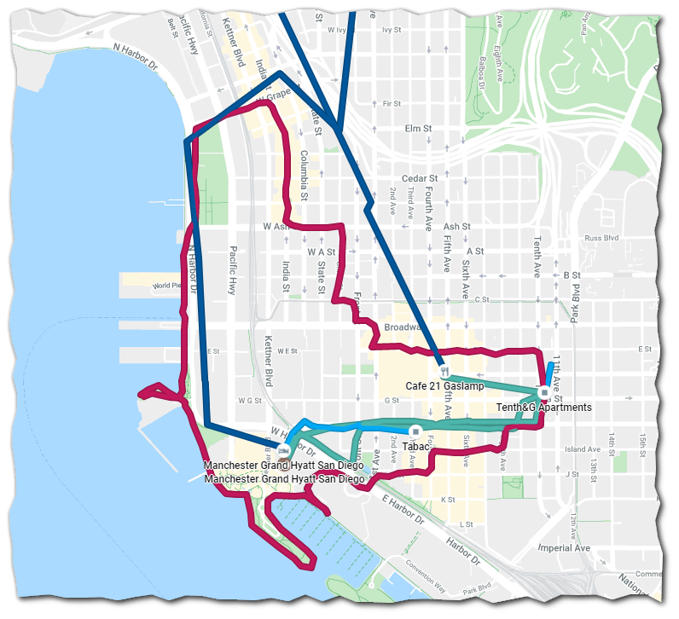

To Come Off WFH Isolation
JM Addington will follow the CDC guidance (which KCHD currently follows) as of April 21st, 2020:
The decision to discontinue isolation should be made in the context of local circumstances. Options now include both 1) a time-since-illness-onset and time-since-recovery (non-test-based) strategy, and 2) test-based strategy.
Time-since-illness-onset and time-since-recovery strategy (non-test-based strategy)
Knox County’s re-opening plan implicitly endorses this strategy
Persons with COVID-19 who have symptoms and were directed to care for themselves at home may discontinue isolation under the following conditions:
- At least 3 days (72 hours) have passed since recovery defined as resolution of fever without the use of fever-reducing medications and
- Improvement in respiratory symptoms (e.g., cough, shortness of breath); and,
- At least 7 days have passed since symptoms first appeared.
Test-based strategy (simplified from initial protocol) Previous recommendations for a test-based strategy remain applicable; however, a test-based strategy is contingent on the availability of ample testing supplies and laboratory capacity as well as convenient access to testing. For jurisdictions that choose to use a test-based strategy, the recommended protocol has been simplified so that only one swab is needed at every sampling.
Persons who have COVID-19 who have symptoms and were directed to care for themselves at home may discontinue isolation under the following conditions:
- Resolution of fever without the use of fever-reducing medications and
- Improvement in respiratory symptoms (e.g., cough, shortness of breath) and
- Negative results of an FDA Emergency Use Authorized molecular assay for COVID-19 from at least two consecutive nasopharyngeal swab specimens collected ≥24 hours apart (total of two negative specimens). See Interim Guidelines for Collecting, Handling, and Testing Clinical Specimens from Persons Under Investigation (PUIs) for 2019 Novel Coronavirus (2019-nCoV)for specimen collection guidance.
Persons with laboratory-confirmed COVID-19 who have not had any symptoms may discontinue isolation when at least 7 days have passed since the date of their first positive COVID-19 diagnostic test and have had no subsequent illness provided they remain asymptomatic. For 3 days following discontinuation of isolation, these persons should continue to limit contact (stay 6 feet away from others) and limit potential of dispersal of respiratory secretions by wearing a covering for their nose and mouth whenever they are in settings where other persons are present. In community settings, this covering may be a barrier mask, such as a bandana, scarf, or cloth mask. The covering does not refer to a medical mask or respirator.
If an employee was put on WFH isolation due to a known or suspected exposure they may come off of WFH isolation after, (1) passing the above criteria, (2) have a negative COVID-19 PCR test taken five to seven days after the initial exposure.

Appendix 1: References Used for this Document
OSHA, COPVID-19 Control and Prevention
https://www.osha.gov/SLTC/covid-19/controlprevention.html

CDC: Cleaning and Disinfecting Your Facility
https://www.cdc.gov/coronavirus/2019-ncov/community/disinfecting-building-facility.html

CDC: Prepare your Small Business and Employees for the Effects of COVID-19
https://www.cdc.gov/coronavirus/2019-ncov/community/guidance-small-business.html

CDC: Interim Guidance for Businesses and Employers to Plan and Respond to Coronavirus Disease 2019 (COVID-19)
https://www.cdc.gov/coronavirus/2019-ncov/community/guidance-business-response.html

CDC: Discontinuation of Isolation for Persons with COVID-19 Not in Healthcare Settings (Interim Guidance)
https://www.cdc.gov/coronavirus/2019-ncov/hcp/disposition-in-home-patients.html

EPA: List N: Disinfectants for Use Against SARS-CoV-2
https://www.epa.gov/pesticide-registration/list-n-disinfectants-use-against-sars-cov-2

OSHA: Guidance on Preparing Workplaces for COVID-19
https://www.osha.gov/Publications/OSHA3990.pdf

Appendix 2: Procurement
Liquid alcohol hand sanitizer
Available from Junction 35 Spirits in Pigeon Forge, https://junction35spirits.com/

Spray bottle for alcohol
https://www.amazon.com/Pack-Chemical-Resistant-Bottles-Sprayer/dp/B078YZQZYX/ref=sr_1_64?dchild=1&keywords=spritz%2Bbottle&link_code=qs&qid=1587478804&sr=8-64&swrs=332307AAB9782AE868EFC0EEEF37F6CA&th=1
https://www.amazon.com/Bottles-Portable-Refillable-Plastic-Material/dp/B07CXG2FRR/ref=sr_1_29?dchild=1&keywords=spritz%2Bbottle&link_code=qs&qid=1587478728&sr=8-29&th=1

Peroxide
GFS, Surety Concentrated Hydrogen Peroxide General-Purpose Cleaner, Liquid, Green Seal Certified, 1 Gal, 4/Case
Item Number: 687880
This must be diluted down to 3-5% for safe use.

Employee Self Monitoring Form
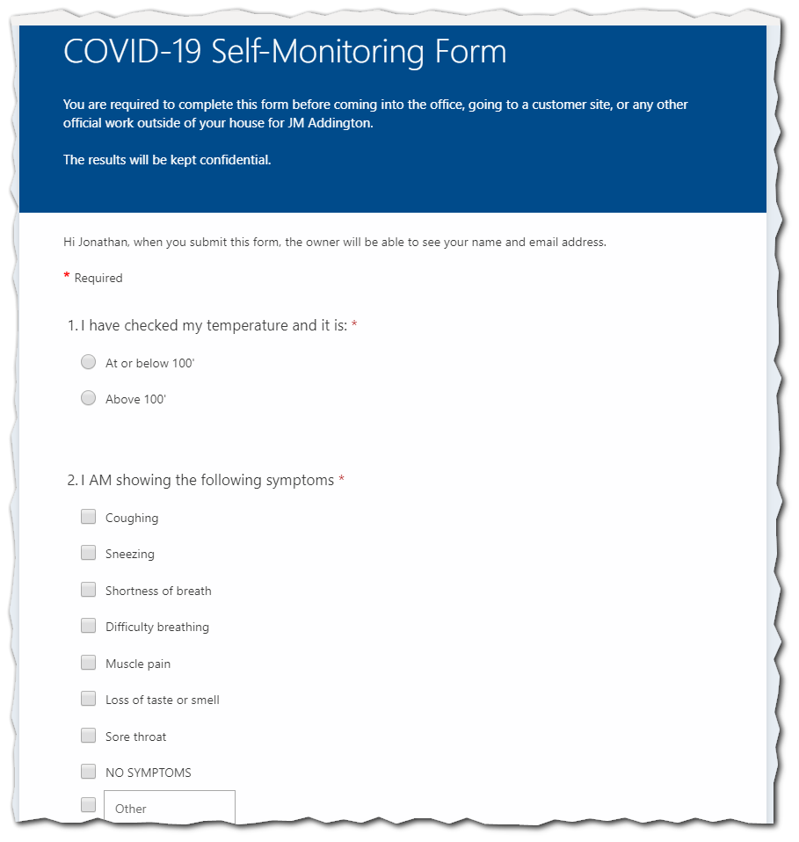
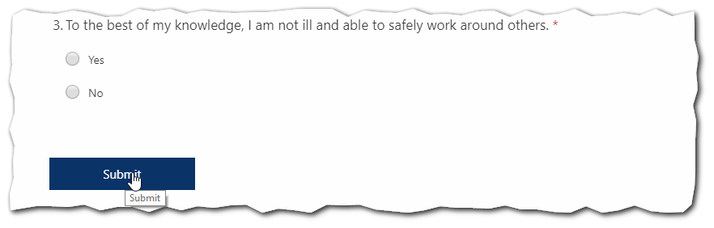
Employees have to, essentially, be symptom free to be allowed to work anywhere from home. Some of the lesser symptoms are a judgement call, primarily sneezing.
Also, we’ll note that most medical guidance would suggest asking about vomiting and diarrhea. While there is as sound medical basis for this symptom we decided that the intrusive nature of asking about bowel movements on a daily basis would lead to low-compliance. The compromise was to ensure that all staff understand that diarrhea is a common symptom and to allow them an “other” box to check as needed.

We will use the most specific guidance issued by KCHD, TDH or CDC, in that order. I.e., if KCHD has general guidance by TDH has industry specific guidance we will default to TDH.
https://www.osha.gov/SLTC/covid-19/controlprevention.html
https://www.epa.gov/pesticide-registration/list-n-disinfectants-use-against-sars-cov-2
https://www.cdc.gov/coronavirus/2019-ncov/hcp/disposition-in-home-patients.html

